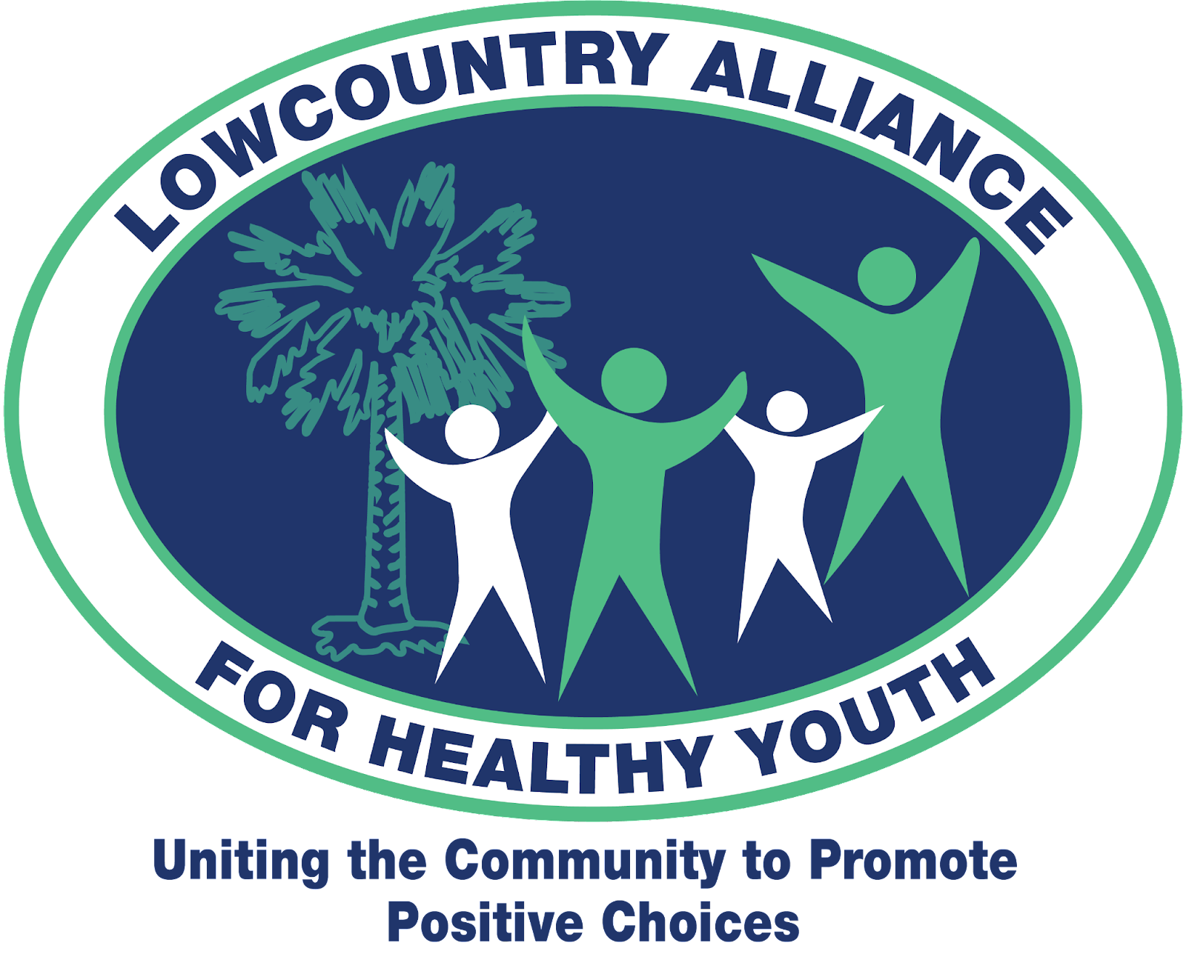

[**https://www.lcahealthyyouth.com/**](https://www.lcahealthyyouth.com/)

**Lowcountry Alliance for Healthy Youth Senior Service Recognition Award APPLICATION PACKET 2025**

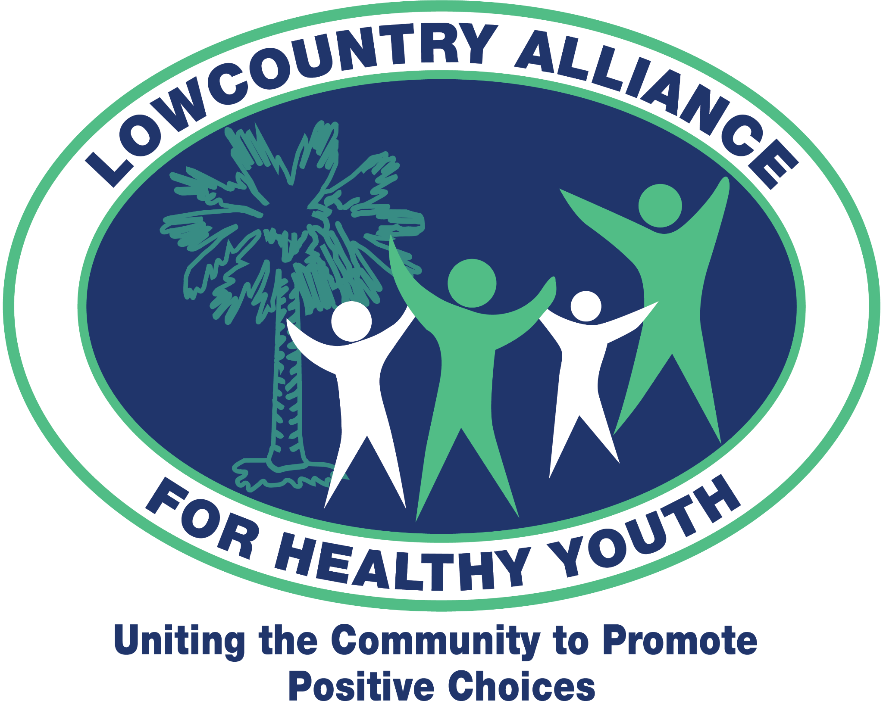 

**LowCountry Alliance for Healthy Youth Senior Service Recognition Award**

**Purpose**: To recognize, honor, and award outstanding Teens for Healthy Youth (THY) senior(s). THY is an initiative of the LowCountry Alliance for Healthy Youth (LCAHY), a community prevention coalition serving Southern Beaufort County uniting the community to promote positive choices and healthy lifestyles for our youth. THY candidates must demonstrate the following:

* Involvement in Teens for Healthy Youth and LowCountry Alliance for Healthy Youth activities and programs
* Dedication to THY’s vision to promote positive teen health

**Requirements:**

The applicant must be:

1. an active member of Teens for Healthy Youth for at least two years.
2. a graduating senior.
3. be accepted to a college, post-high school educational/technical program, or military.
4. submit a completed application form and attachments by the deadline date.

**Award:** The LowCountry Alliance for Healthy Youth will provide a monetary award for the selected recipient(s). The scholarship money is given to the recipient(s) directly.

**Deadline**: **Friday, April 4th, 2025**

**Applications received after the deadline will not be considered.**

Forward All Questions to:

Mrs. Laura Pirkey

LCAHY Youth Coordinator/THY Coordinator

[laurapirkey@gmail.com](mailto:laurapirkey@gmail.com)

843-384-3351

**Instructions:**

Applicants must complete and *submit enclosed forms 1-3 electronically*, these must be typed (hand-written forms will not be accepted). It is the applicant’s responsibility to ensure that all forms are received by LCAHY via email to: [lcalliance4healthyyouth@gmail.com](mailto:lcalliance4healthyyouth@gmail.com) by **April 4th, 2025**. ***Forms & recommendations should be sent together in one email***. Please do not send numerous emails.

* **From 1 Application Form**: This must be filled out completely and have your name typed in the signature line at the bottom of the page (serving as an electronic signature).
* **Form 2 Applicant Statement**: **This form, along with your applicant statement, must be accompanied by a list of accomplishments specific to THY/ LCAHY**. In other words, write about and detail your involvement in THY and LCAHY. A list of what is to be included in the Applicant Statement is indicated on the form. **(Do not include other club activities, non-THY/LCAHY volunteer activities, or academic accomplishments.)**
* **From 3 Letter of Reference**: Applicants must collect two letters of reference. One must be the THY Advisor and the other may be a teacher or community leader who knows the applicant well and their capacity as a THY member. **Individuals who write letters of reference must write about the applicant's involvement with THY and LCAHY.** (Do not include information on other club activities, non-THY/LCAHY volunteer activities, or academic accomplishments.)

The selection committee will review the applications and select the number of qualified applicants.

**Applicants must attend the Teens for Healthy Youth Recognition Event on Wednesday, April 23rd, 2025, at 6 PM at Hilton Head Christian Academy Performing Arts Center**. Parents and school officials are also invited to attend.

**Form 1: Application Form**

Applicant Name:

Applicant’s Address:





Applicant’s Phone number:

High School currently attending:



School Mailing Address:

School Phone Number:

College or post-secondary education program you plan to attend: 

Anticipated course of study or program: 

List the two people who will be submitting letters of reference:

THY Advisor: 

Teacher/Community Member

Statement: I have read and accepted the rules and the eligibility requirements to be considered for this recognition award. I certify that all information in my application is accurate to the best of my knowledge. I consent to the review and release of this application to the appropriate person(s) in LCAHY.

Applicant’s Electronic Signature

Date: 

**Form 2: Application Statement**

Name of Applicant Date 

Applicant Statement Requirements for LCAHY’s Senior Service Recognition Award:

* Must be neatly **typed** and presented in an organized format
* Must be at least one page, but no more than two pages long
* Must include personal, educational, and career goals
* **Must include a list with a very detailed description of your involvement in THY & LCAHY**
* **Do not include information about other clubs, service organizations, or academics!**

***Include your applicant statement and a detailed explanation of activities/involvement in THY/LCAHY with this form****. Please submit to*[lcalliance4healthyyouth@gmail.com](mailto:lcalliance4healthyyouth@gmail.com).

**Form 3: Letter of Reference (2 required)**

___________________ is applying for the LCAHY Senior Service Youth Recognition Award for his/her exceptional participation in Teens for Healthy Youth/Lowcountry Alliance for Healthy Youth. Teens for Healthy Youth are dedicated to promoting positive teen health through leadership, peer-to-peer education, and service. The award is given to a senior(s) who are members of Teens for Healthy Youth and who exemplifies:

* Involvement in Teens for Healthy Youth and LowCountry Alliance for Healthy Youth activities and programs
* Dedication to THY’s vision to promote positive teen health

Please be specific and candid in your remarks. The applicant will submit the references with the other forms in one email to the LCAHY office.

Please be sure to include the following in your **typed** letter of reference:

* How long have you known the candidate?
* In what capacity do you know the person?
* Why do you consider this person deserving of this award?
* **Describe the candidate’s participation in Teens for Healthy Youth and Lowcountry Alliance for Healthy Youth include a detailed description.**
* **Do NOT include information about other clubs, service organizations, or academics.**



Name of Reference:



Reference’s Email:



Reference’s Phone Number:

***To be considered for this award, your letter of reference must be emailed by the applicant with Forms 1-3*** [lcalliance4healthyyouth@gmail.com](mailto:lcalliance4healhtyyouth@gmail.com) **no later than April 4th, 2025.**